Key Instant Recall Facts
Y6 – Autumn 2
I can add and subtract fractions
Key facts and vocabulary

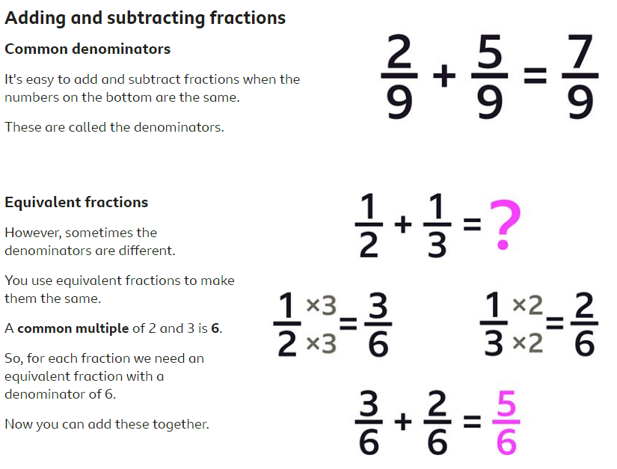

Key Vocabulary:
Fraction, equal part of a whole, denominator, numerator, equivalence

Taking it further:
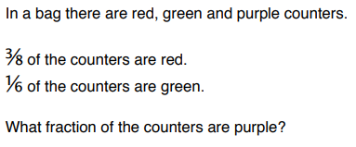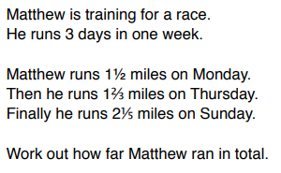

Top Tips
The secret to successfully embedding knowledge is practising it little and often. Regularly return to the skills and incorporate into simple games and other activities.

Ideas:
Chanting – count in a fraction, switching between improper fractions and mixed numbers (eg. ¼, 2/4, ¾ ,1 ,1 ¼, 1 ½, 1 ¾ etc)
Quick questions: 2/8 + 4/8 =
1 1/5 – 2/5 =
Think about: Spot the common denominator (use your factors and multiples knowledge)
Is your answer in the simplest form?
Can you represent the question as a diagram or bar model?

- Use websites for information and games:
- https://www.bbc.co.uk/bitesize/topics/zhdwxnb/articles/z9n4k7h
- https://www.youtube.com/watch?v=5juto2ze8Lg
- https://www.khanacademy.org/math/cc-fifth-grade-math/imp-fractions-3/imp-adding-and-subtracting-fractions-with-unlike-denominators/v/adding-small-fractions-with-unlike-denominators
- https://corbettmaths.com/2013/02/15/adding-fractions-same-denominator/
- https://corbettmaths.com/2012/08/21/fractions-addition-and-subtraction/

