Key Instant Recall Facts
Y5 – Summer 2
I can find and recognise square, cube, prime and composite numbers
Key facts and vocabulary

A square number is a number multiplied by itself. For example if we have 2 x 2, the result is 4, which is a square number. The next square number would be found by 3 x 3 (9 is the square number), and so on. It might also be written like this: 5² means 5 squared, so would be calculated by 5 x 5, so 5² = 25
If we were to take some squared paper and colour a square, the first size would be 1 x 1, which gives 1 as a square number. Then you could colour a square that is 2 x 2, then 3 x 3 and so on. The total number of coloured squares would be the square number.

If we know the square numbers, then we should also know their ‘square root’: the square number is 16, so the square root is 4; the square root of 25 is 5.

A cube number is a number multiplied by itself and itself again, so 2 cubed (2³) would be 2 x 2 x 2 = 8, and 3 cubed would be 3 x 3 x 3 = 27.
To build a cube number you could use little cubes – to work out 4 cubed (4³), you would first create a square of four by four cubes, then build it up so that it was four layers tall: 4 x 4 x 4 = 64.
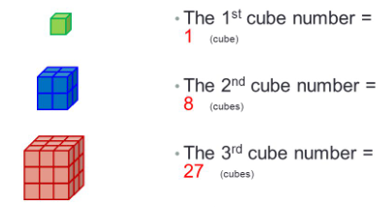

A prime number has only two factors – 1 and itself – it is not in any of the times tables (except 1 and itself). For example, 5 is a prime number because only 1 and 5 can divide exactly into it. The same is true of 2, 3, 7, 11, 13,17 and 19 (the prime numbers less than 20). Those numbers that are not ‘prime’ are ‘composite’. That is, they have three or more factors.

Key Vocabulary:
Factor, multiple, square, cube, prime, composite, root
Taking it further:
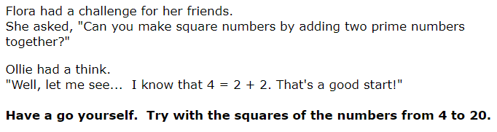
https://nrich.maths.org/1150

Top Tips
The secret to successfully embedding knowledge is practising it little and often. Regularly return to the skills and incorporate into simple games and other activities.

Ideas:
Chanting – write out the first twelve square numbers and repeat them as a sequence.
Look at those numbers and say the square root of each as a sequence.
Recite the prime numbers below 30.
Quick questions: What are the first twelve square numbers?
What is the third prime number?
How many cubes are needed to build the second cube number?
Think about: You have 50 little cubes, what is the largest cube you can make?
Is 51 a prime number? How do you know?

- Use websites for information and games:
https://corbettmathsprimary.com/?s=cube+numbers
https://corbettmathsprimary.com/?s=square+numbers
https://www.bbc.co.uk/bitesize/topics/zyhs7p3/articles/z2ndsrd
https://corbettmathsprimary.com/?s=prime+numbers
https://www.topmarks.co.uk/maths-games/hit-the-button
https://www.transum.org/Maths/Activity/Prime/
https://www.mathsisfun.com/prime-composite-number.html

