Key Instant Recall Facts
Y5 – Summer 1

I can add and subtract fractions
Key facts and vocabulary

Fractions equal parts of a whole denominator numerator equivalence multiple

Adding and subtracting fractions with the same denominator is straightforward:
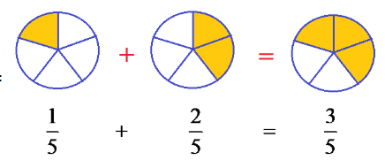
We add the numerators. In this example, we have added how many fifths there are in total.
If we were subtracting, the same ‘rule’ applies: Three fifths subtract two fifths equals one fifth.

However, if the fractions have different denominators, we need to find a common denominator. That means we need to find a multiple of both denominators (what do they both ‘go into’?).
So to solve the question 1/2 + 1/3 we need to think of a common multiple of 2 and 3. Using our number knowledge, we know that 6 is a common multiple.

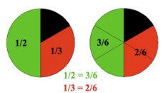
So now we have 3/6 + 2/6 which is 5/6 (see above).

Taking it further:
What happens if the fraction is a mixed number? If this is the case, first change it into an improper fraction.

1 2/3 + 2 1/2 becomes 5/3 + 5/2 (because there are three thirds in one whole and two halves in one whole, so four halves in two wholes).

We then follow the steps above – find a common denominator (both 3 and 2 are factors of 6):
5/3 + 5/2 = 10/6 + 15/6

Then add the numerators: 25/6

Then convert back to a mixed number (because that was the format we started with):
Think ‘how many 6’s in 25?’ (25 divided by 6), answer is 4 with one left over, so this means that there are 4 wholes and 1/6, so 25/6 = 4 1/6

Top Tips
The secret to successfully embedding knowledge is practising it little and often. Regularly return to the skills and incorporate into simple games and other activities.

Ideas:
Quick questions: What is 4/5 – 3/5?
What is 1 1/2 - 2/3?
Amy has two equal lengths of rope. She uses a quarter of one rope for one project and two thirds of the other rope for another. What fraction of her rope does she have left?

- Use websites for information and games:
https://www.bbc.co.uk/bitesize/topics/zhdwxnb
https://www.math-play.com/adding-and-subtracting-fractions-game.html
https://www.mathplayground.com/fractions_add.html

