Know and Recall Facts
Y2– Autumn 2

I can recall my 2 times table
Times tables |  | Key Vocabulary
Children should understand the concept of multiplying by 2, and recall multiplication facts.  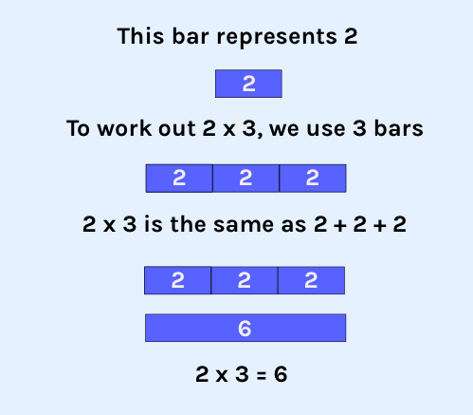 | 2 x table  2 x 1 = 2  2 x 2 = 4  2 x 3 = 6  2 x 4 = 8  2 x 5 = 10  2 x 6 = 12  2 x 7 = 14  2 x 8 = 16  2 x 9 = 18  2 x 10 = 20  2 x 11 = 22  2 x 12 = 24 | 2 multiplied by 5 equals 10  2 times by 3 = 6  20 divided by 2 = 10  There are 8 lots of 2 in 16.
Take it further:
Discussion about the solutions – counting in twos, same as doubling, all even numbers.
Missing answer questions e.g. 2 x __ = 8
Worded questions e.g. There are six children at a party. They will each eat two cakes. How many cakes need to be baked? What would you rather have; 16 sweets or 7 lots of 2 sweets?
Fact families

3x2=6 6=3x2
2x3=6 6=2x3
6÷2=3 3=6÷2
6÷3=2 2=6÷3
Top Tips
The secret to successfully embedding knowledge is practising it little and often. Regularly return to the skills and incorporate into simple games and other activities.

Ideas:
- Go back to counting in twos to begin with. Check they are confident with this.
- Chanting tables
- Quick questions/Flash cards
- Times Tables Songs
  - https://www.bbc.co.uk/teach/supermovers/times-table-collection/z4vv6v4
- Times Tables Rockstars
  - https://play.ttrockstars.com/
  - Each child has their own login – it can be accessed through the website above or by downloading the app.
  - Children should work through specific questions in the ‘Garage’ to practise specific tables for them; play games in the ‘Studio’ and challenge themselves at a ‘Sound Check’.
  - All children should be challenging themselves to improve their accuracy and speed.

