Key Instant Recall Facts
Y1– Summer 1
This is our foucs for this half term.
I can make doubles up to 20.
Doubles | Key Vocabulary
Year 1 children need to be able to understand that ‘double’ is two groups of a number or an amount.  They can show what doubling means by using concrete and pictorial representations.  They can say doubles as a sentence ‘Double ____ is____’  Recognise a double as a repeated addition. | Double  Double fact  Two groups of…  Two lots of…  Twice  Repeated addition
Take it further:
- Recognise when something is a double and when something isn’t a double – sorting dominoes.
- Apply doubles know to identify further doubles e.g. knowing the can work out double 11 by using knowledge of double 10 and double 1 and adding these together to identify double 11.
- Use double knowledge when adding a near double e.g. 6+7=___. So, 6+6=12, so 6+7 is one more than that, so 6+7=13.

Top Tips
The secret to successfully embedding knowledge is practising it little and often. Regularly return to the skills and incorporate into simple games and other activities.

Ideas:
Start by developing this knowledge through the use of concrete equipment (Lego, pasta, beads, buttons, small toys, fingers etc.). Think about how these objects are placed to aid the quick identification of the double. Numicon shapes would also be a useful resource.

Then progress to drawing pictorial representations of the double – drawing circles, squares or lines. Again, think carefully about how the drawing is presented to aid quick identification of the double.

Finally, find ways for children to be able to rapidly recall the double.

Always begin each stage in sequence and then work out of sequence.

Game and activities:
- Dominoes
- Roll a dice and double that number.
- Doubles bingo
- Create your own chant (see below) or a song https://www.youtube.com/watch?v=At0quRa90rs
- Online games:
-https://www.topmarks.co.uk/Flash.aspx?f=dartboarddoublesandhalves (just reveal answers doubles (10)
- https://www.topmarks.co.uk/maths-games/hit-the-button (Hit the Button, Doubles – Double to 10. )
- https://www.ictgames.com/mobilePage/archeryDoubles/index.html
- https://www.sheppardsoftware.com/mathgames/monkeydrive/addition/MDAddDoubles.htm
- http://www.maths-games.org/ladybird-doubles.html
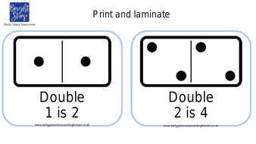
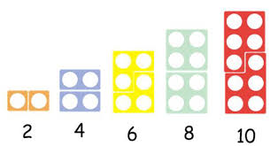
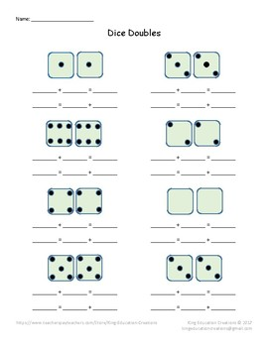
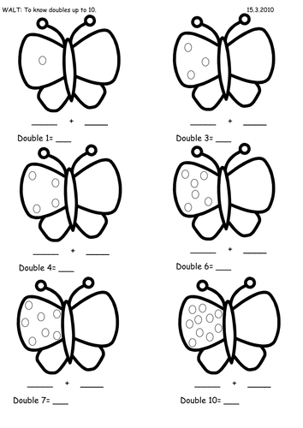
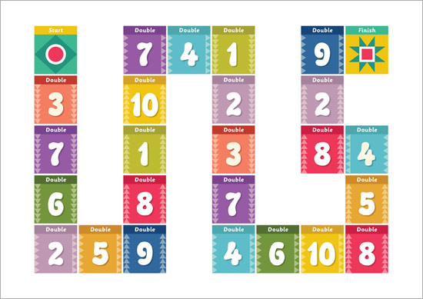
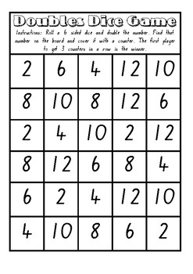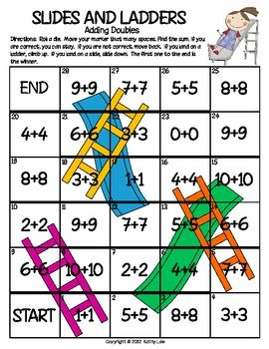

Doubles chant

Double 1 is 2, 2, 2,
I went to the zoo, zoo, zoo.
Double 2 is 4, ,4 ,4,
Can you hear the lion roar?
Double 3 is 6, 6, 6,
The monkeys can do lots of tricks.
Double 4 is 8, 8, 8,
Please remember to close the gate.
Double 5 is 10, 10, 10.
Keep the tigers in the pen.
Etc.

