Key Instant Recall Facts
Y1– Autumn 2

I can recall the number bonds up to and including ten.
Number bonds | Key Vocabulary
Children should be confident in identifying number bonds within 10:  e.g. Number bonds to 6  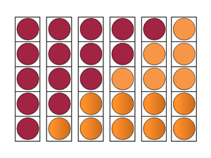  5 + 1 = 6  4 + 2 = 6  3 + 3 = 6  2 + 4 = 6  1 + 5 = 6  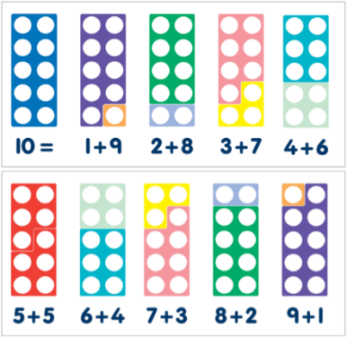  Children should be able to recall and represent all number bonds to 10:  e.g. | 5 add 3 equals 8  2 more than 4 = 6  7 and 3 make 10  If 3 is a part and 2 is a part, then 5 is the whole
Take it further:
Use addition facts to record related subtraction facts. E.g. If 5 add 3 equals 8 then 8 subtract 5 equals 3.
Spot patterns within and between numbers.
Missing number problems e.g. 4 + ___ = 7
Spot and explain mistakes.

Top Tips
The secret to successfully embedding knowledge is practising it little and often. Regularly return to the skills and incorporate into simple games and other activities.

Ideas:
- Chanting / songs / rhymes
  - https://www.youtube.com/watch?v=heZp5RVT5a8
  - https://nurseryrhymescollections.com/lyrics/number-bonds-to-ten.html
- Matching pairs of numbers to make a target total.
- Beat the clock – 4 minutes to see how many facts they can recall.
- Save the Whale
  - http://www.ictgames.com/saveTheWhale/
- Hit the Button
  - https://www.topmarks.co.uk/maths-games/hit-the-button
- If I have 4, how many do you need to get to 10?
- Throw a ball and say a number. Child needs to respond with a number bond before they catch it. Score a point for each correct response.
- Tell me everything you know about 7
- Flash cards – show them and children recall what that number bond makes.

