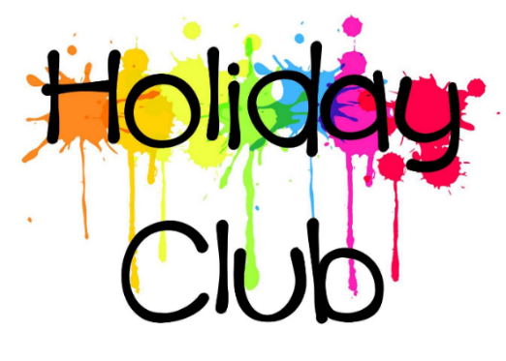
CHADDESLEY CORBETT ENDOWED PRIMARY SCHOOL AND NURSERY
USEFUL INFORMATION

In order for things to run smoothly Please provide your child with the following items:
- packed lunch with a drink
- named refillable drinks bottle
- coat
- hat and gloves (if cold weather)
- sun hat and sun cream (if warm weather)
- sensible shoes for running around in
- pair of wellies if it’s raining or wet outside
- a large old t shirt/shirt to protect clothes if painting etc
For certain activities they will also need:
- Scooter Day - scooters and helmet
- Forest School - clothes suitable for Forest school (and a change of clothes in case of muddy accidents!)
- Wet Play day – swimming costume, towel, PE pumps (the playground gets VERY hot in the sun!)
Nursery/Reception age children:
- Spare clothes in case of accidents
- Changing bag with nappies/wipes/nappy bags etc if not yet toilet trained.

PLEASE NOTE:
Children may bring a light snack with them to have during the morning and/or afternoon. If it is too early for breakfast before leaving home, children can also bring breakfast with them and eat it here.
Alternatively, breakfast and a light tea are available at extra cost. Breakfast is served from 8.00-9.00am. A light tea is served from 5.00-5.30pm. Please refer to Fees and Charges for more information.

