|  |  |
| --- | --- |
| **Topic words** | |
| Traditional | Tales |
| Fiction | Countries |
| Setting | Characters |
| Forest | Castle |
| Beanstalk | Cottage |
| River | Materials |
| Once upon a time… | …and they all lived happily ever after |

Our topic this term is ‘Traditional Tales.’ Through this topic we will be reading lots of Traditional Tales, such as the Three Little Pigs, Goldilocks and the Three Bears, Jack and the Beanstalk, Anansi the Banana Thief and The Gingerbread Man. We will be retelling these stories using the Talk for Writing approach. Puppets, text maps, role play and actions will aid the children in recalling each of the stories.

**What is a traditional tale?**

A Traditional Tale is a story that has been told and re-told for many years and is a story that almost everyone knows.

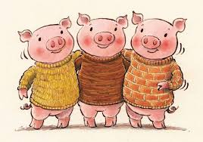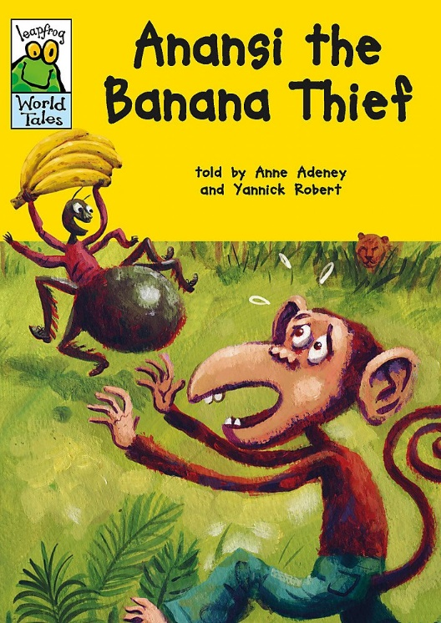

**What did the pigs use to build their houses?**

The Three Little Pigs built their houses out of bricks, sticks and straw.

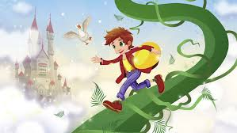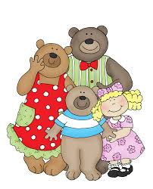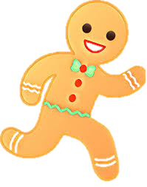

**Can you name at least three ‘baddies’ from the stories that we have read?**

Goldilocks, the wolf, the giant and the fox are all ‘baddies.’

**What happens at the end of the Gingerbread Man?**

The fox eats the gingerbread man at the end of the story.

**Where do Anansi stories come from?**

Different countries have different traditional tales. Tales about Anansi the Spider are often told in Ghana, Africa.

**Other ‘Traditional Tales’ books that you might like to read:**

* The Jolly Postman (Janet and Allan Ahlberg)
* Usbourne Illustrated Fairy Tales
* Usbourne Fairytales for Little Children
* Ladybird First Favourite Tales