Geography: London and the South East
River Thames Exploration:  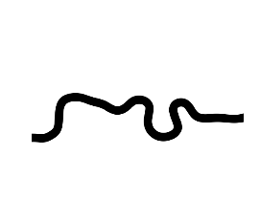  The River Thames is a significant feature in London and the South East. Find out more about the river, including its length, major bridges that cross it, and its importance to the region. You could create a poster illustrating the course of the river and its key features. | 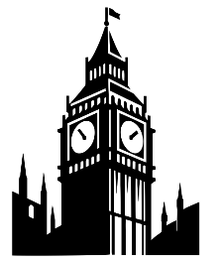  London Landmarks:  Reasearch the history of a famous London landmark, such as Big Ben, The Palace of Westminster, the Tower of London or London Bridge. Create a fact file or tourist information leadlet for one of them. | 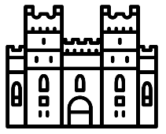  Windsor Castle:  Plan a day trip to Windsor Castle or another famous SE England attraction. Include details of the route, the ticket prices and a plan what you would do once there.
History: The Stuarts- part 1
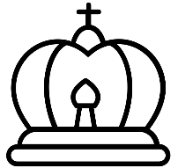  Biography of James I  Create a biography poster or booklet about James I. Include important facts about his life, such as his upbringing, family, achievements, and contributions to English history. Include illustrations or pictures to make the biography visually engaging. | The Gunpowder Plot  create a storyboard illustrating the events of the Gunpowder Plot. You can draw or use pictures to depict key moments such as the conspirators' planning, the discovery of the gunpowder, and the aftermath of the failed plot. | 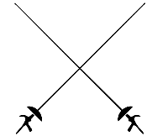  The English Civil War  Research and create a map of the key battles of the English Civil war. Find out more about the Cavaliers and roundheads and what each side believed in.

