Key Instant Recall Facts
Y3 – Spring 1
I can tell the time on an analogue clock
There are several ways to read analogue clocks (eg 8:35am, 35 minutes past 8, 25 minutes to nine) and this can be very confusing to learn. However, it is an important skill which should become embedded before leaving primary school. Please take every opportunity to practise this term.
How many seconds in a minute/minutes in an hour/hours in a day?
What do am and pm mean?
Which hand marks the hour/minutes/seconds?
How many minutes past which hour?
How many minutes to the next hour?
When do we use quarter past/half past/quarter to?

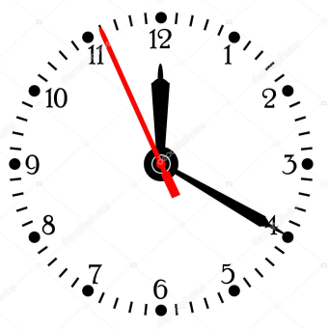
Top Tips
The secret to successfully embedding knowledge is practising it little and often. Regularly return to the skills and incorporate into simple games and other activities.

Ideas:
  - Wear a watch and use it
  - Have clocks on display and ask what time it is and help with answer
  - Watch ‘How to tell the time’ videos on YouTube
  - Complete the time-related activities on Purple Mash
  - Play time games on www.topmarks.co.uk
Challenges:
  - Estimate how long something will take and time how long it actually takes
  - Work out duration from start and finish times
  - Read train/bus timetables together

