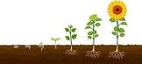
How Does Your Garden Grow?
Our new topic is ‘How does your garden grow?’ Within this topic, we will be looking at the story, ‘The Enormous Turnip’ and using puppets, pictures and props to retell the story. We will also be learning the story using the Talk for Writing approach. The children will also have the opportunity to grow their own plants and take on the responsibility of looking after them.

Topic words
Seed | Stem
Leaves | Flower
Roots | Sow
Water | Soil
Sunlight | Plant

Plants need the following thigs to grow –
- Water
- Soil
- Sunlight
- Air
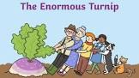
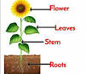
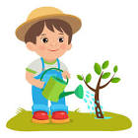
Key Questions
- What do plants need to grow?
- What are the different parts of a plant?
- Who helped pull out the turnip in the story of ‘The Enormous Turnip’?
- Can you name any flowers?
Daffodils, daisies and tulips are some flowers that you might find in your garden.
Other ‘Growing’ books that you might like to read:
- Oliver’s Vegetables (Vivian French)
- How Does My Garden Grow? (Gerda Muller)
- Jack and the Beanstalk
- Titch (Pat Hutchins)
- The Tiny Seed (Eric Carle)

