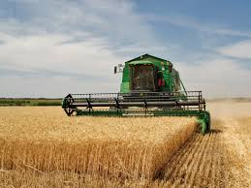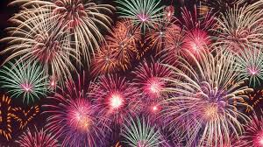**Celebrations**

Our topic this term is ‘Celebrations.’ Through this topic, we will be learning about different festivals including Harvest, Bonfire Night, Diwali and Christmas! We will be developing our speaking and listening skills to share our own experiences of these celebrations. Here are some of the things we are going to be learning about to help you continue your learning at home.

The book that we will be reading in class is ‘The Little Red Hen.’

We will be retelling this story using Talk for Writing,

puppets, story maps and actions.

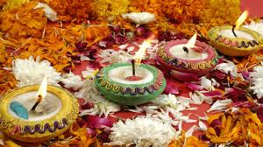

|  |  |
| --- | --- |
| **Topic words** | |
| Celebration | Beliefs |
| Diwali | Harvest |
| Special | Festival |
| Christmas | Growing |
| Light | Fireworks |

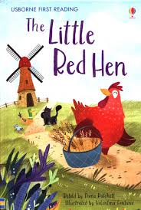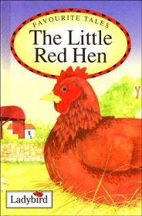

What is Diwali?

What is Harvest?

How do people celebrate Harvest?

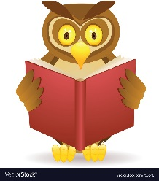

Who do we celebrate at Christmas time?

**Other books about ‘Celebrations’ that you might like to read:**

* Oliver’s Vegetables (Vivian French)
* Handa’s Surprise (Eileen Browne)
* Hovis the Hedgehog (Lynda Leigh-Crawford)
* Amy’s Light (Robert Nutt)
* Lights (Monica Hughes)
* Night Animals (Sam Meredith)

**Our ‘Celebration’ facts**

* Harvest is the time of year when crops are ripe.
* People celebrate Harvest by having a Harvest Festival.
* Diwali is the Hindu festival of light.
* Bonfire night is when we remember the Gunpowder plot.
* At Christmas, we celebrate the birth of Jesus.