How to order logoed School Uniform items from Tesco
All logoed items of School Uniform (except for Tracksuits & ties) will be available for you to buy directly from Tesco F&F
Pre-School: https://www.tesco.com/direct/pre-school-uniform/21448.school?source=others
Main School: https://www.tesco.com/direct/main-school-uniform/21447.school
You will see the range available when you log in using the links above. One link is for the Nursery Pre-School items and the other for the Main School.
PLEASE NOTE: Polo shirts are only for our Nursery children, they are not part of the main school uniform.
Nursery parents may choose to buy the polo shirt in green or white.
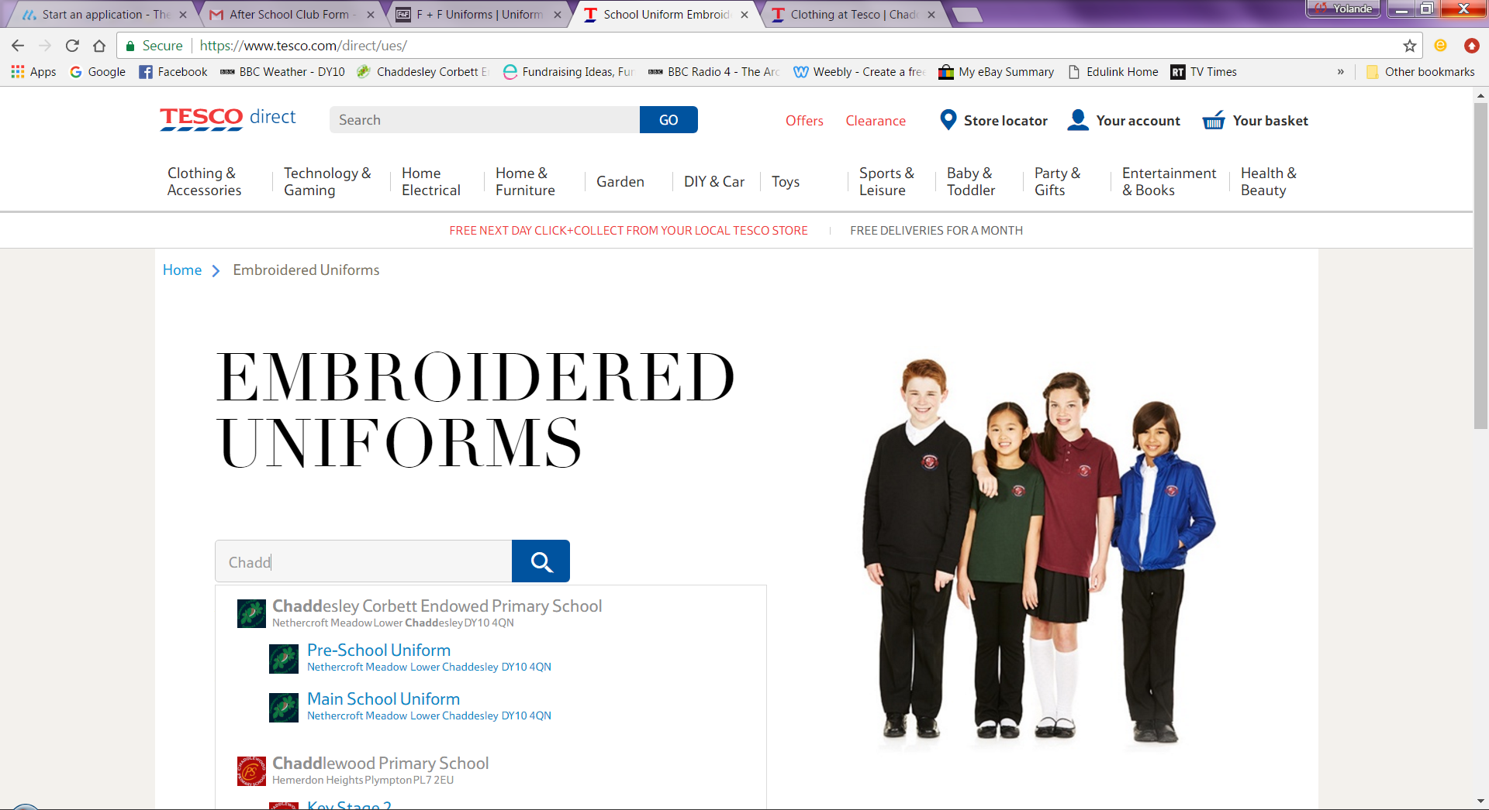
Items ordered will be delivered directly to you at home and if you have a Tesco Club card you can earn points on your purchases.
School will continue to sell the tracksuits and ties.
