Key Instant Recall Facts
Y1– Summer 2
This is our foucs for this half term.
I can halve numbers up to 20.
Halving numbers | Key Vocabulary
Year 1 children need to be able to understand that to find half of an amount the total is split into two equal groups. Half is one out of the two equal groups. It is the opposite (inverse) of double.  They can show halving by using concrete and pictorial representations.  They can state it as a sentence ‘Half of ____ is____’  Half of 2 is 1.  Half of 4 is 2.  Half of 6 is 3.  Half of 8 is 4.  Half of 10 is 5.  Half of 12 is 6.  Half of 14 is 7.  Half of 16 is 8.  Half of 18 is 9.  Half of 20 is 10. | Half/One half  Halve  Halving  Halves  Share/Split into two equal groups/parts

Take it further:
- Recognise when something is half and when something is not a half – link to knowledge of odd and even numbers.
- Apply halves knowledge to identify further halving questions e.g. knowing they can work out half of 12 by using knowledge of half of 10 and half of 2 and adding these together to identify half of 12.

Top Tips
The secret to successfully embedding knowledge is practising it little and often. Regularly return to the skill and incorporate into simple games and other activities.

Ideas:
Start by developing this knowledge through the use of concrete equipment (Lego, pasta, beads, buttons, small toys, fingers etc.). Ideally have a piece of paper folded in half and use this for the children to share objects into two equal groups. Get them to place objects carefully, so they are able to quickly identify the amount in each group. They will need to learn to check they groups are equal. To state half they need to say how many is in one of the equal groups.

Then progress to drawing pictorial representations – drawing circles, squares or lines. Again, use a piece of paper folded in half or draw a shape and split it in half and then draw in the pictures. When drawing get them to continue to share between the two groups. Think carefully about how the drawing is presented to aid quick identification of the double.

Finally, find ways for children to be able to rapidly recall half of each number.

Always begin each stage in sequence and then work out of sequence.

Game and activities:
- Create your own chant (see below)
- Online games:
-https://www.topmarks.co.uk/Flash.aspx?f=dartboarddoublesandhalves (Half (15))
- https://www.topmarks.co.uk/maths-games/hit-the-button (Hit the Button, Halves – Halves to 10)
- Ping Pong – In this game, the parent says, “Ping,” and the child replies, “Pong.” Then the parent says a number and the child doubles it. For a harder version, the adult can say, “Pong.” The child replies, “Ping,” and then halves the next number given.
- Double or Halve? A two-player game. https://nrich.maths.org/10654
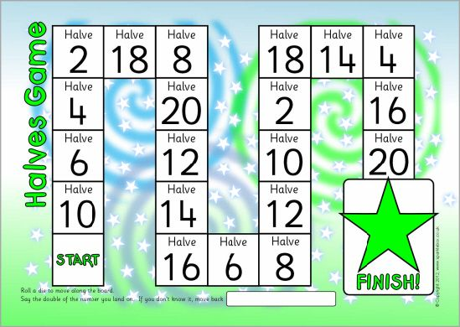
https://www.twinkl.co.uk/resource/t-n-1148-doubling-and-halving-board-game

Half of 2 is 1,1,1,
Let all sing this song, song, song.
Half of 4 is 2, 2, 2,
What can you do, do, do?
Half of 6 is 3, 3, 3,
Why don’t you climb a tree, tree, tree?
Etc.

