Topic: Northern Europe
These activities will immerse the children in their new topic, the British Isles. At school, the children will be learning about the following:
- Countries in Northern Europe – Denmark, Finland, Norway, Sweden and Iceland.
- Human and physical features of Northern Europe
- Climate in Northern Europe
- Animals found in Northern Europe and Migration
- The Great Explorer - Roald Amundsen
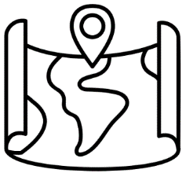  Mapwork:  Provide maps of Northern Europe and help children identify and label countries such as Norway, Sweden, Denmark, Finland, and Iceland. Discuss the locations of these countries and their relative positions on the map. | 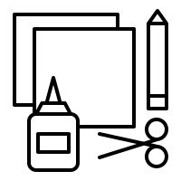  Arts and crafts:  Introduce children to the phenomenon of the Northern Lights (Aurora Borealis) and show them pictures or videos of this natural light display. Then, provide materials for children to create their own Northern Lights artwork using paints, chalk, or pastels. | Landform Model Making:  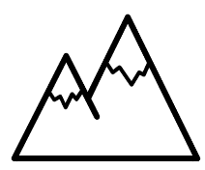  Help children create 3D models of physical features in Northern Europe, such as mountains, fjords, and glaciers, using materials like clay, playdough, or papier-mâché. Discuss the formation and significance of these landforms. | 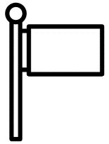  Exploring Northern European Flags:  Show children the flags of Northern European countries and discuss the symbolism and meaning behind the colours and symbols used. They can then create their own flags representing imaginary Northern European nations, explaining their choices.
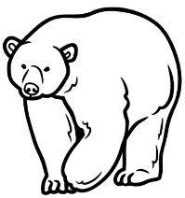  Matching Game:  Prepare cards with pictures of animals found in Northern Europe, such as reindeer, polar bears, puffins, and moose, along with cards showing their respective habitats (e.g., tundra, forests, coastlines). Children can match the animals to their habitats and learn about the diverse wildlife of the region. | 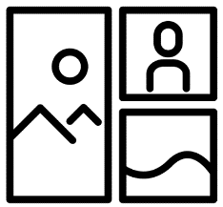  Collage:  Provide pictures or cut outs representing human and physical features of Northern Europe, such as mountains, rivers, cities, and landmarks. Have children create collages by arranging these pictures on paper and discussing their significance. | 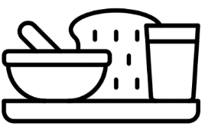  Exploring Nordic Culture: Introduce children to aspects of Nordic culture, such as traditional clothing, food, and holidays. They can participate in activities like making Swedish meatballs, crafting paper snowflakes, or learning about the Midsummer festival celebrated in Scandinavia. | 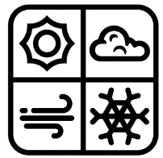  Weather Experiment:  Set up a simple rain gauge using a clear plastic bottle with measurements marked on the side. Place the gauge outside in an open area, and children can check it daily to measure the amount of rainfall. They can record their observations in a weather journal.

This homework is not compulsory!
If your child completes any of these activities, please post to Class Dojo or bring them to school so we can put them on display and celebrate your child’s effort.

